Microwave Photonics for Modern Radar Systems
题名：字号15磅，行距固定值16磅，段后回行1次
作者名：字号12磅，单倍行距，段后8磅，英文斜体，姓全部，并用空格隔开。通信作者“*”标出。不同单位作者加注单位上角标
首页页眉：字号9.5磅，单倍行距，段后1.2磅
文后请附每位作者的个人简介

PAN Shilong*, ZHU Dan, ZHANG Fangzheng
Key Laboratory of Radar Imaging and Microwave Photonics, Ministry of Education, College of Electronic and Information Engineering, Nanjing University of Aeronautics and Astronautics, Nanjing 210016, P. R. China
单位名：单位名称字号10磅，段后8磅。不同单位用1.2.3.分列，分号隔开
(Received 18 January 2014; revised 20 February 2014; accepted 5 March 2014)
日期：字号9.5磅，段后0回车换行1次
Abstract: The emerging new concepts and technologies based on microwave photonics have led to an ever-increasing interest in developing innovative radar systems with a net gain in functionality, bandwidth/resolution, size, mass, complexity and cost when compared with the traditional implementations. This paper describes the techniques developed in the last few years in microwave photonics that might revolutionize the way to design multifunction radar systems, with an emphasis on the recent advances in optoelectronic oscillators, arbitrary waveform generation, photonic mixing, phase coding, filtering, beamforming, analog-to-digital conversion, and stable radio-frequency signal transfer. Challenges in implementation of these components and subsystems for meeting the technique requirements of the multifunction radar applications are discussed.
摘要：字号9.5磅，行距可按版面调整
Key words: microwave photonics; radars; multifunction; optoelectronic oscillator; phase coding; optical mixing; arbitrary waveform generation; optical switching
关键词：字号9.5磅，分号隔开
CLC number：TN925 Document code: A Article ID: 1005-1120(2014)03-0219-21
请勿忘提供中图分类号

0 Introduction
一级标题：由0开始编号，实词首字母均大写，字号12磅，段前段后均为8磅；
二级标题：字号10磅，首字母大写，其余均小写；
三级标题（不提倡）：字号10磅，斜体，段前0.5行

The modern use of radar is highly diverse, including air traffic control, radar astronomy, marine radars for locating landmarks and other ships, aircraft/vehicle anticollision systems, outer space surveillance and rendezvous systems, meteorological precipitation monitoring, altimetry and flight control systems, ground-penetrating radar for geological observations, and military systems for wide-area search, target tracking, and fire control^{[1]}. Several of the above functions may be required in a single platform. However, due to the different requirements of frequency band, bandwidth, waveform, and signal processing methodology, most of these functions can only be implemented using an independent electromagnetic system. This presents a lot of problems, including increased weight and size, increased antenna blockage, electromagnetic interference, increased radar cross section, and maintenance issues because each system has its own unique set of spare parts, operators, and repair personnel^{[2]}. Fig. 1 shows the block diagram of a typical radar system, consisting of local oscillators (LOs), waveform generators, modulators, filters, mixers, amplifiers, antennas, analog-to-digital converters (ADCs), signal processors, computers, and power supplies. If most of these components can be shared by the radars with different functions (usually at different frequency bands), multifunction radar with reduced space, weight, power, cost and demands for human operators is possible ^{[3]}. However, it is very difficult for the state of the art electronic technologies to operate the microwave components in multiple frequency bands without sacrifice of the performance. In addition, the calibration of the system would be a critical issue because the electrical devices always have different insertion losses, phase shifts and reflection coefficients in different frequency bands. To solve these problems, many microwave technologies were developed, ranging from the multiband mixers^{[4]}, receivers^{[5]}, transceivers^{[6]} to detectors^{[7]} and antennas^{[8-9]}, but all of them were realized at the expense of significant increase of the weight, size, complexity, electromagnetic interference or power consumption.
第一作者为学生的，通信作者请改为导师，并提供通信作者的职称和E-mail

字母缩写，在文中首次出现需给出全称，之后均用缩写

图、表的文字描述需先于图、表本身出现

正文：字号10磅，行距13—16磅，按排版需要进行调整。首行缩进两字符。含有上下标或较复杂数学式的段落为多倍行距，设置值1.1~1.2
DOI编码规则：期刊分配号、年、期、页码
参考文献：按文中出现的先后顺序在右上角标注，中括号内由”-“连接起止

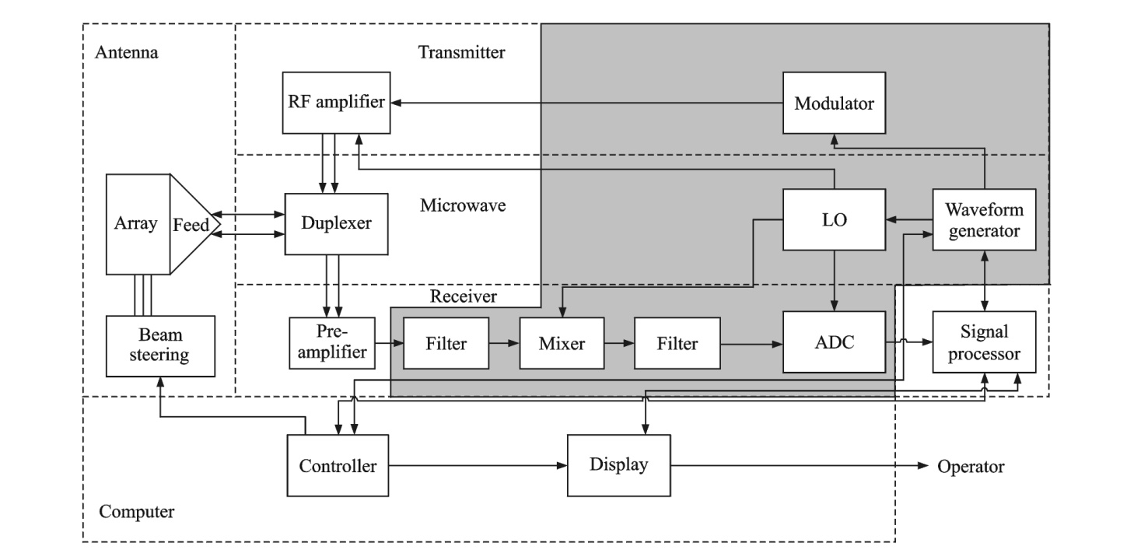
图中出现的缩写、变量请在正文中说明解释

Fig. 1 Schematic diagram of a typical radar system
图题：字号9磅，行距固定值11磅，段前8磅，段后10磅。图中字号8磅
若有(a),(b),(c),…分图，需给出分图图题

On the other hand, microwave photonics, which brings new opportunities to revolutionize the microwave components and systems, has evolved significantly in scope and technical maturity over the past 30 years^{[10]}. As defined by many pioneers in this area^{[10-14]}, microwave photonics is an interdisciplinary field that studies the interactions between microwave and optical waves for the generation, processing, control, distribution and measurement of microwave, millimeter-wave and THz-frequency signals. Table 1 lists several key aspects of the performance difference between the conventional microwave system and the microwave photonic system. Thanks to the broad bandwidth, low loss, light weight, flat frequency response, and immunity to electromagnetic interference provided by the photonic technologies, microwave photonics may allow innovative implementation of the multiband reconfigurable radar with significant added value.
图、表的文字描述需先于图、表本身出现

Previously, there were considerable efforts devoted to applying the fast developing microwave photonic technologies to the radar systems, which can date back to the early 1990s^{[15-27]}. Examples include the trials to construct phased array radar based on photonic true time delay and the proposals to build photonic radio-frequency (RF) front-end. In 2009, the European Research Council (ERC) granted a project entitled PHODIR (Photonic-based full digital radar, Dec. 2009 - Dec. 2013), focused on the study, design and realization of a full
表格：三线表，表中文字首字母大写，其余均小写，字号8磅，行距固定值11磅，段后回车换行1次
Table 1 Performance comparison between the conventional microwave system and microwave photonic system
Parameter | Microwave system | Microwave photonic system
Frequency range  表中数值的单位请前置，放在栏目部分，并用“/”与物理量隔开 | Tens of GHz | THz  阿拉伯数字三位一空
Instantaneous bandwidth | Several GHz | Tens of GHz
Transmission loss / (dB·m^{－1}) | ~0.6 | 0.000 2
EMI | Serious | Immue
Weight | Heavy (EMI shielding) | Light
Size | Big | Small
Isolation | Low | High

digital transceiver radar demonstrator based on photonic technology both for signal generation and for RF received signal processing^{[28]}. A photonic radar was built and demonstrated in a field trial at the port of Livorno, Italy. Based on PHODIR, another project PREPARE (Pre-industrial photonic-based radar design) was set up recently, aimed to address the research on the specific application for the airport security, providing a pre-industrial design. Meanwhile, the Europe seventh framework programme (FP7) established a project named GAIA (Photonics front-end for next-generation SAR applications, Oct. 2012—Oct. 2015), to develop the photonic technologies required in future array antenna systems for the implementation of the next generation synthetic-aperture radar (SAR) applications for future Earth observation missions^{[29]}.
表示起止用“一字线”（中文破折号的一半）
In this paper, techniques developed in the last few years in microwave photonics that might change the way to design modern radar systems are reviewed. The recent advances in optoelectronic oscillators, arbitrary waveform generation, photonic mixing, phase coding, filtering, beamforming, analog-to-digital conversion, and stable RF signal transfer are described. Challenges in implementation of these components and subsystems for meeting the requirements of the radar applications are discussed.
1 Optoelectronic Oscillator
The ability of modern radar to detect low target signatures in clutter and hostile jamming environment is highly dependent on the quality of the transmitted signal, the receiver, and the data processing^{[30]}. As an essential part in the modern radars (as shown in Fig. 1), a microwave generator not only determines the quality of the RF signal in the transmitter and the intermediate frequency (IF) signal in the receiver, but also serves as a time standard for signal processing modules, by which, for example, the signal delay is measured to extract the range information. In modern radar systems, the phase noise of a microwave source is one of the key performance limiting factors^{[31-32]}. Due to the phase noise, weak targets would be hidden by strong unwanted echoes even if the echo from the target has Doppler shift. The spurious level is another key parameter of the microwave source which should be carefully considered in the radar systems. Without the high side mode-suppression ratio (SMSR), the false alarm probability will be significantly increased. Thanks to the capability of ultra-low phase noise microwave signal generation, OEOs^{[33-34]} have received much attention for potential radar applications in the past two decades. Fig.2 shows the schematic diagram of a typical OEO, which is a feedback loop consisting of an intensity modulator, a high-Q optical storage element (e. g. a length of fiber), a photodetector (PD), an electrical amplifier, an electrical bandpass filter (EBPF), and an electrical phase shifter. When a continuous-wave (CW) lightwave is injected into the modulator, the OEO starts to oscillate at one of its eigenmodes determined by the center frequency of the EBPF if the net gain of the loop is greater than unity. The spacing between two adjacent eigenmodes is determined by the total length of the loop.

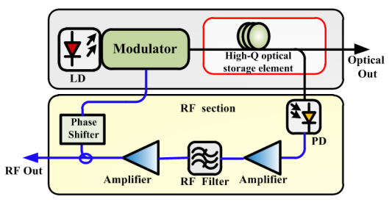

Fig.2 Block diagram of a typical OEO[34]
The phase noise performance of an OEO is directly related to the Q-factor of the loop. In general, the longer the fiber in the OEO, the lower the phase noise^{[34]}. But the flicker noise of the amplifiers, the laser relative intensity noise (RIN), the shot noise in the PD and the noise introduced by the optical reflection would create a noise floor in the phase noise spectrum. Previously, considerable efforts were devoted to reduce this noise floor. By using amplifiers with lower flicker noise and high-Q filters, the phase noise performance was improved^{[35]}. A fiber-optic implementation of the carrier-suppression technique was demonstrated to reduce the close-to-carrier noise of a triple-loop OEO^{[36]}. About 20 dB phase noise reduction at 10 Hz away from the 10 GHz carrier is realized. The laser RIN can be significantly reduced by inserting an optical power limiter after the laser, and the noise associated with the PD can be largely suppressed by operating the PD in the saturation limit. In addition, through laser frequency modulation, the noise due to the reflection in optical
数字和单位之间空一格
connectors or splices and double Rayleigh scattering in fiber can be reduced^{[37]}.
The mode selection and spurious level are determined by the EBPF in the OEO loop. For a single loop OEO, the modes close to the peak frequency will have large possibility to oscillate, and spurious will show up at these sidemodes^{[38]}. With the increasing of the fiber length, which is always adopted to improve the phase noise performance of the OEO, the mode spacing becomes narrower and the spurious level will be high, because the ability of the EBPF to remove the supermodes is always limited. By using a high Q microwave or optical filter, the SMSR will be improved. A possible approach is to incorporate an ultrahigh-Q whispering gallery mode resonator (WGMR) in the OEO^{[39]}. A typical Q value of the WGMR is greater than 10⁹, which can be used to select only one mode in a loop with a length of several kilometer. Another way to effectively suppress the undesired sidemodes is to apply multiple loops^{[37,40-43]}. By introducing additional fiber loops with shorter lengths in parallel with the long fiber loop, the Vernier effect would form additional filtering in the OEO cavity. For example, in a dual-loop frequency-doubling OEO based on polarization modulation and polarization multiplexing^{[43]}, an SMSR of 78 dB is realized for a fundamental microwave signal at 9.95 GHz or a frequency-doubled signal at 19.9 GHz. In addition, a section of unpumped EDF in a coupled OEO (COEO)^{[44]} can serve as a mode-restricting device through spatial hole burning effect, which can also significantly improve the SMSR of the OEO.
Frequency hopping is widely used in modern radars, thus fast and wideband tunability of the microwave source is also required. The tunability of the OEO can be realized by incorporating a tunable EBPF in the loop^{[35,45]}. But the frequency tuning range is limited due to the electronic bottle neck. To overcome the problem, a frequency-quadrupling OEO was reported, in which the frequency-quadrupling structure in the output branch improves the tuning range by four times^{[45]}. Another way to realize tunable OEOs is to form a tunable microwave photonic bandpass filter in the OEO loop^{[46-51]}. For example, a widely tunable OEO was reported based on a tunable microwave photonic filter formed by a polarization modulator (PolM) and a chirped fiber Bragg grating (FBG) together with a polarization beam splitter (PBS)^{[50]}. The chirped FBG serves as a dispersive element (DE). By changing the polarization state between the PolM and the PBS, simultaneously amplitude modulation and phase modulation with the ratio between them adjustable are formed, which leads to a shift of the transmission response. In this way, a tunable microwave photonic filter is formed to realize a coarse selection of the oscillation mode in the OEO. The dual-loop configuration is used to achieve the fine frequency tuning. A tuning range of 5.8—11.8 GHz is realized. In addition, an interesting tunable OEO based on the stimulated Brillouin scattering (SBS) effect was reported to convert a low-quality and low-frequency IF signal to a high-quality and high-frequency signal without introducing any high-Q electrical filter^{[52]}. A single-sideband suppressed-carrier modulated signal generated by modulating a poor-quality IF signal is used as the Brillouin pump wave, and a phase-modulated signal at the same wavelength is used as the probe signal. A high-Q microwave photonic filter realized by the selective amplification of the SBS effect is used for mode selection in the OEO. By tuning the Brillouin pump wave, a wide tuning range is realized. High quality microwave signals from 10.15 to 42.15 GHz are experimentally generated by applying low quality IF signals.
Another strict requirement of the microwave source in the modern radars, especially the airborne and space-based radars, is small size and low power consumption. A lot of works have been done to reduce the size of the OEO. One way is to replace the long fiber in the OEO loop by high-Q optical resonators, which could be WGMRs^{[34,53,54]} or fiber ring resonators^{[55-56]}. With the high-Q WGMRs, OEOs in a package smaller than a coin can be realized without sacrifice of the performance^{[34]}. However, optical coupling and wavelength alignment will be very difficult, and sophisticated circuits should be employed to make the OEO work stably. By using a directly modulated laser (DML) to replace the laser source and the intensity modulator, one device and its related control circuit can be saved to reduce the OEO size^{[57-58]}. However, the DMLs under large signal modulation would lead to a broad linewidth of the optical carrier, resulting in poor phase noise performance. To further reduce the size of the OEO, a compact OEO based on an electroabsorption modulated laser (EML) was proposed^{[59]}. The EML can replace the laser source, intensity modulator and PD, so that the OEO can be miniaturized by saving two devices and the corresponding drive circuits. The phase noise with the generated 9.945 GHz signal is −101.31 dBc/Hz, showing that the compact OEO has an acceptable performance.
2 Photonic Arbitrary-Waveform Generation
For a radar system, the properties of the signal emitted by the antennas, such as the power, the temporal waveform, and the spectral bandwidth, will determine the detection range, resolution, and the anti-interference ability. In modern radar systems, programmable and diverse complicated waveforms are needed to increase the resolution and meet the fast-switching requirements, thus, AWG is becoming more and more important. In the current stage, the most commonly used electrical AWG in a radar system is realized by the direct digital frequency synthesis (DDS)^{[60]}. The DDS technology offers great flexibility for switchable waveform generation, but it suffers from the limited operation bandwidth which is usually lower than a few GHz. Because the radar systems are evolving towards working at high frequency and large bandwidth, optical arbitrary waveform generators (OAWGs) become a promising solution because it can generate high frequency and large bandwidth waveforms through optical technologies and then convert the optical signal into electrical arbitrary waveforms for radar applications. Besides the huge bandwidth, OAWG also features low cost, low loss and immunity to EMI,
etc. Up to now, several kinds of OAWG have been successfully demonstrated, showing the great potential for their use in radar systems.
An OAWG can be realized by optical spectral shaping followed by frequency-to-time mapping (FTTM)^{[61]}. Fig.3 shows the fundamental principle of this method. The system is usually composed of a pulsed laser source, an optical spectral shaper, a DE and a PD. The spectrum of the pulsed laser source is modified by the optical spectral shaper. Then, FTTM is performed in the DE, which can be a length of dispersive fiber or a chirped FBG. Mathematically, the impulse response of a DE is^{[62]}
公式中π、自然对数的底e、虚数单位i,j用正体
$h\left(t\right)∝\exp\left(j\frac{π}{2\ddot{Φ}}t^{2}\right)$ (1)
where $\ddot{Φ}$ is the second-order dispersion of the DE. If the temporal width $∆t_{0}^{2}$ of the input pulse $a_{in}(t)$ is small enough to let $\left|∆t_{0}^{2}\right|≪\left|2π\ddot{Φ}\right|$, the output signal after the PD is^{[63]}
公式中的矩阵、向量、张量需用黑斜体
${I\left(t\right)=R\left|a_{out}(t)\right|}^{2}=C^{2}R{\left|F\left[a_{in}(t)\right]\right|}_{ω=t/{\ddot{Φ}}}^{2}$(2)
where C is a constant and F denotes the Fourier transformation, $R$ is the responsivity of the PD. As can be seen from Eq.(2), the generated electrical signal is a scaled version of the input optical power spectrum. As a result, by designing the optical spectral shaper with arbitrary power transfer function, arbitrary waveform can be generated.
所有字母符号在公式中第一次出现需给出详细说明

Fig. 3 Schematic diagram for waveform generation based on optical spectral shaping and FTTM

The key component in an OAWG based on spectral shaping and FTTM is the optical spectral shaper, which can be implemented based on free-space optics^{[64]} or fiber optics^{[65-67]}. Fig. 4 shows the structure of a typical optical spectral shaper, where the input optical pulse is first dispersed spatially by a grating and a spatial light modulator (SLM) array is used to implement optical spectral shaping before the dispersed light is combined by another grating. The advantage of using an SLM for spectral shaping is that the spectral response of an SLM can be updated in real time, making the generation of an arbitrary waveform possible. The main limitation of a

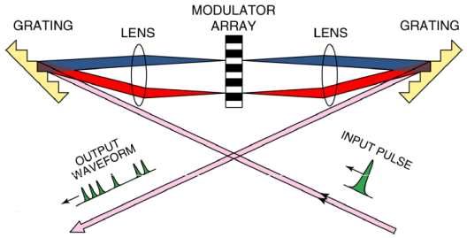

Fig.4 Optical spectral shaper based on free-space-optics^{[63]}
free-space-optics-based spectral shaper is the large size and high loss. In addition, the coupling between fiber to
free-space and free-space to fiber makes the system complicated. On the other hand, a spectral shaper can be implemented based on fiber optics. A fiber-optic spectral shaper has the advantages of smaller size, lower loss, and better compatibility with other fiber-optic components. For instance, a scheme for the generation of frequency and phase tunable pulsed microwave waveform based on spectral shaping and FTTM through all fiber optics is demonstrated with the schematic diagram shown in Fig.5(a). The optical spectral shaper is a tunable optical comb filter consisting of a differential group delay (DGD) element, a PolM and a polarizer^{[68]}. By passing a short optical pulse through the tunable comb filter and a DE, a pulsed microwave signal is generated after optical-to-electrical conversion. The phase of the generated microwave signal can be continuously tuned by tuning the voltage applied to the PolM, as shown in Fig.5(b). Thanks to the large bandwidth of the PolM, phase modulation of the microwave signal as high as tens of GHz can be achieved. Besides, the frequency of the microwave signal can be tuned by changing the DGD and/or the dispersion of the DE, as shown in Fig.3(c).
Another method for OAWG is Fourier pulse shaping based on an optical frequency comb (OFC). By manipulating the OFC to have certain amplitude and phase properties corresponding to the Fourier transformation of the target pulse waveform, the target waveform can be obtained in the time domain^{[69]}. The key issues for OAWG by Fourier pulse shaping is the generation of a wideband OFC and manipulating both the amplitude and the phase of the OFC. A mode locked laser (MLL) can generate an OFC with a comb line spacing being the same as the temporal interval between adjacent short pulses in the time domain^{[70]}. The method for OFC generation suffers from poor stability and a high cost, and it is also hard to obtain a flatted spectrum. A cost-effective approach to generating a stable and flat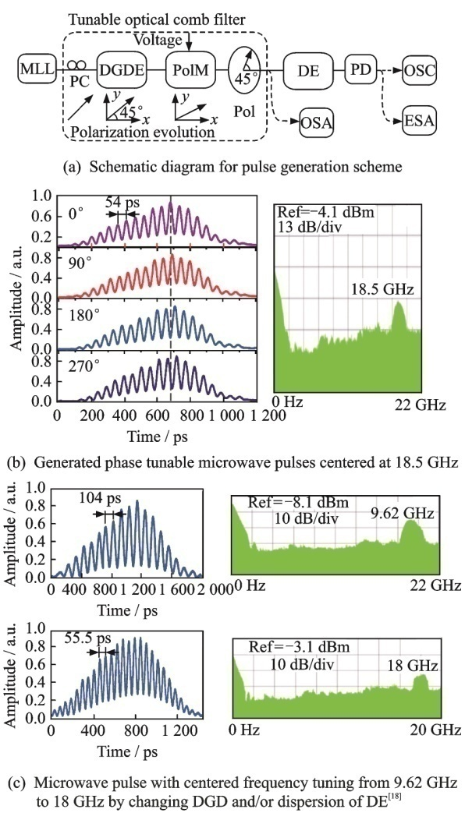
没有标值相对应的小标值线请去掉
应注明纵横坐标表示的物理量及单位，且物理量与单位之间用斜杠“/”分隔
Fig.5 Schematic diagram for pulse generation and the experimental results
OFC is to modulate a CW light by electro-optic modulators^{[71-72]}. The flatness of the obtained OFC can be less than 1 dB in the power spectrum^{[71]}. To complete the Fourier pulse shaping based on the generated OFC, an optical processor that can manipulate the amplitude and phase of the comb is necessary. There have been commercially available optical processors that can perform this task, and the principle is almost the same as that shown in Fig. 4.
We have recently demonstrated an OAWG scheme based on Fourier pulse shaping^{[73]}. The OFC is generated by modulating a CW light through an electro-absorption modulator (EAM) and two cascaded electro-optic phase modulators (PMs), which has a comb line spacing of 40 GHz, 3 dB bandwidth of 3.8 nm and an optical signal-to-noise ratio (OSNR) of 40 dB. Then, using a commercially available programmable optical processor (Finisar Waveshaper-4000S) with a spectral resolution of 1 GHz, Fourier pulse shaping is implemented by designing the transfer functions of the optical processor
… … …
9 Discussion and Conclusions
This paper reviewed the recent development of microwave photonics for potential applications in radar systems, with an emphasis on the following technologies that are closely related to the radar functionality and performance: optoelectronic oscillators, arbitrary waveform generation, photonic mixing, phase coding, filtering, beamforming, analog-to-digital conversion, and stable radio-frequency signal transfer. These photonic technologies have been proved to have superior performance than their electrical counterparts, in terms of operation bandwidth, size, mass, and complexity, etc. Current research advances are encouraging, sufficiently showing the promising potentials of microwave photonics for radar applications, especially for future multifunctional and high performance radars. Despite the intense research activities carried out during the past three decades, there is still a considerable room for improvement. Several expected future developments are discussed as follows.
(1) The compatibility of different microwave photonic subsystems must be improved to integrate multiple microwave photonic functions in a single platform. The microwave photonic oscillators, arbitrary waveform generators, mixers, phase coders, filters, beamformers, analog-to-digital convertors are currently implemented based on different laser sources (i.e. CW, tunable, comb and pulsed laser sources), modulation schemes (i.e. phase modulation, intensity modulation, polarization modulation, and parallel or cascaded electrooptic modulation) and detection methods (i.e. direct detection, coherent detection, single-end or balanced detection). Some implementations require optical filtering, which may affect the realization of some other microwave photonic functions. The mechanism for adding tunablility or reconfigurability to some microwave photonic subsystem may also degrade the performance of other microwave photonic technologies.
(2) Continuous efforts should be devoted to the improvement of the performance of the devices and subsystems, while at the same time reducing the cost. Modern radars demand critically for large bandwidth, high sensitivity, large dynamic range of the RF systems. While microwave photonic technologies have superior performance in term of bandwidth, the sensitivity is low due to the high noise figure of the electrical-to-optical or optical-to-electrical conversion, and the dynamic range is relatively low because of the nonlinearity and low efficiency of the modulators and detectors.
(3) The microwave photonic systems must include antennas, RF amplifiers and other electronic devices or modules, but almost none of them is designed dedicatedly for the microwave photonic applications, which limited the potential of microwave photonics in practice. To solve this problem, hybrid design of the electrical and optical system is required.
(4) Most of the microwave photonic systems are realized based on discrete optical or electrical components, which is bulky, complicated, unstable, and power consuming. Photonic integrated circuit is a promising solution to this limitation. Significant advances were achieved in the past few years, and were recently reviewed in Ref.[159], but many microwave photonic functionalities are still not demonstrated on a chip. Therefore, more efforts to make the microwave photonic system compact, light, cheap, reliable and low power consuming are needed.
References:
参考文献数量不少于15篇，以近5年发表的论文为主，文献作者3名以内全部列出，4名以上只列前3名，后加 “，et al.”。作者姓前名后，姓全部大写，名缩写为首字母，不加缩写点。文献应是文中直接引用的公开出版物，且在文中引用处用“［文献序号(右上角标)］”顺序标注，中文参考文献应译成英文并加（in Chinese）。
所有文献请严格按以下格式著录，不符合规范的将退回作者重新修改。
- 专著
主要责任者.题名：其他题名信息[M](或[M/OL]).其他责任者.版本.出版地：出版者，出版年：引文页码[引用日期].获取和访问路径. DOI.
PEEBLES P Z, Jr. Probability, random variable, and random signal principles[M]. 4th ed. New York: McGraw Hill, 2001.
BALDOCK P. Developing early childhood services: past, present and future[M/OL]. [S.l.]: Open University Press, 2011:105 [2012-11-27]. http://lib.myilibrary.com/Open.aspx?id=312377.
- 连续出版物
主要责任者.题名：其他题名信息[J](或[J/OL]).年，卷(期)-年，卷(期).出版地：出版者，出版年[引用日期].获取和访问路径. DOI.
KANAMORI H. Shaking without quaking[J]. Science,1998, 279(5359): 2063.
MYBURG A A, GRATTAPAGLIA D, TUSKAN G A, et al. The genome of Eucalyptus grandis[J/OL]. Nature, 2014, 510: 356-362(2014-06-19)[2014-06-25]. http://www.nature.com/nature/journal/v510/n7505/pdf/nature13308.pdf. DOI:10.1038/nature13308.
- 专利文献
专利申请者或所有者.专利题名：专利号[P](或[P/OL]).公告日期或公开日期[引用日期].获取和访问路径. DOI.
TACHIBANA R, SHIMIZU S, KOBAYSHI S, et al. Electronic watermarking method and system: US6915001[P/OL]. 2005-07-05[2013-11-11]. http://
www.google.co.in/patents/US6915001.
- 电子资源
主要责任者.题名：其他题名信息[R/OL](或[EB/OL]).出版地：出版者，出版年：引文页码(更新或修改日期)[引用日期].获取和访问路径. DOI.
HOPKINSON A. UNIMARC and metadata: Dublin core[EB/OL]. (2009-04-22)[2013-03-27]. http://archive.
ifla.org/IV/ifla64/138-161e.htm.

示例：
论文集、会议录
BABU B V, NAGAR A K, DEEP K, et al. Proceedings of the Second International Conference on Soft Computing for Problem Solving, December 28-30, 2012[C]. New Delhi: Springer, 2014.
报告
CALKIN D, AGER A, THOMPSON M. A comparative risk assessment framework for wildland fire management: the 2010 cohesive strategy science report: RMRS-GTR-262[R]. [S.l.: s.n.], 2011:8-9.
学位论文
CALMS R B. Infrared spectroscopic studies on solid oxygen[D]. Berkeley: Univ. of California, 1965.
标准文献
Information and documentation-the Dublin core metadata element set: ISO 158369:2009[S/OL]. [2013-03-24].http://www.iso.org/iso/home/store/catalogue_tc/catalogue_detail.htm?csnumber=52142.

[1] SKOLNIK M I. Radar handbook [M]. 3rd Edition. New York: McGraw-Hill, 2008: 1-24.
[2] TAVIK G C, HILTERBRICK C L, EVINS J B, et al. The advanced multifunction RF concept [J]. IEEE Transactions on Microwave Theory and Techniques, 2005, 53(3): 1009-1020.
[3] SADDIK G N, SINGH R S, BROWN E R. Ultra-wideband multifunctional communications/radar system [J]. IEEE Transactions on Microwave Theory and Techniques, 2007, 55(7): 1431-1437.
[4] HU S, XIONG Y Z, WANG L, et al. A 77—135GHz down-conversion IQ mixer for 10Gbps multiband applications [C]// the 13th International Symposium on Integrated Circuits (ISIC). Singapore: IEEE, 2011: 29-34.
[5] JEON S, WANG Y J, WANG H, et al. A scalable 6-to-18 GHz concurrent dual-band quad-beam phased-array receiver in CMOS [J]. IEEE Journal of Solid-State Circuits, 2008, 43(12): 2660-2673.
[6] JAIN V, TZENG F, ZHOU L, et al. A single-chip dual-band 22–29-GHz/77–81-GHz BiCMOS transceiver for automotive radars [J]. IEEE Journal of Solid-State Circuits, 2009, 44(12): 3469-3485.
[7] ONO H. Power saving type multi-band microwave detector: U.S. Patent 5,389,930 [P]. 1995-2-14[2014-02-10].
[8] CHU R S, LEE K M, WANG A T S. Multiband phased-array antenna with interleaved tapered-elements and waveguide radiators [C]// 1996 IEEE Antennas and Propagation Society International Symposium Digest (AP-S 1996). Baltimore: IEEE, 1996: 1616-1619.
致谢：若不止一个基金号请用复数。字号10磅，行距固定值12磅，段前10磅，段后6磅。
… …

Acknowledgements This work was supported in part by the National Basic Research Program of China (No. 2012CB315705), the Natural Science Foundation of Jiangsu Province (Nos. BK2012031, BK2012381), the National Natural Science Foundation of China (Nos.61201048, 61107063), and the Fundamental Research Funds for the Central Universities. The authors realize that the time and space available for a review of such an ambitious subject are limited and, thus, regretfully, we are unable to cover many important contributions. The authors would like to acknowledge the following people for their assistance: Fu Jianbin, Huang Menghao, Zhang Yamei, Wei Juan, Tang Zhenzhou, Gu Xiaowen, Ye Xingwei, and Wu Huan, all with the Key Laboratory of Radar Imaging and Microwave Photonics, Ministry of Education, Nanjing University of Aeronautics and Astronautics.
Author Prof. PAN Shilong received the B.S. and Ph.D. degrees in electronics engineering from Tsinghua University, Beijing, China, in 2004 and 2008, respectively. From 2008 to 2010, he was a “Vision 2010” Postdoctoral Research Fellow in the Microwave Photonics Research Laboratory, University of Ottawa, Ottawa, ON, Canada. From 2010 to present, he has been with the College of Electronic and Information Engineering, Nanjing University of Aeronautics and Astronautics (NUAA), where he is currently a full professor and executive director of the Key Laboratory of Radar Imaging and Microwave Photonics (NUAA), Ministry of Education. His research has focused on microwave photonics, which includes Radio over fiber, photonic generation of microwave, mm-wave and THz, photonic processing of microwave signals, photonic microwave measurement and photonic integrated circuits.
需要给出所有作者的学术简介
Prof. ZHU Dan received the B.S. and Ph.D. degrees in electronics engineering from Tsinghua University, Beijing, China, in 2004 and 2009, respectively. In July 2009, she joined the Research Department of Radar Signal Processing, No.14 Research Institute, China Electronics Technology Group Corporation, as a researcher. In May 2011, she joined the Photonic Microwave Research Laboratory, College of Electronic and Information Engineering, NUAA, Nanjing, China. From Jul. 2014, she works as a visiting scholar in the Microwave Photonics Research Laboratory, University of Ottawa, Canada.
Dr. ZHANG Fangzheng received B.S degree in Physics from Huazhong University of Science and technology in 2008 and Ph.D. degree in Electronic Engineering from Beijing University of Posts and Telecommunications in 2013, respectively. He joined in Nanjing University of Aeronautics and Astronautics in June 2013, where he is an assistant professor of Microwave Photonics Research Laboratory. His research is focused on high speed coherent optical communication, the optical information processing and relevant fields.
Author contributions Prof. PAN Shilong designed the study. Dr. ZHAO Dan wrote the manuscript. Dr. ZHANG Fangzheng contributed data for the damage detection part. All authors commented on the manuscript draft and approved the submission. (仅供参考)
Competing interests The authors declare no competing in⁃terests.

（Production Editor： ）

