Microwave Photonics for Modern Radar Systems
Author(s)’ name(s)：Centered, 12 pounds, italicized. The order of family name and given name follows the author(s)’ national tradition, only Chinese, Korean, Japanese family names are capitalized. “*”is used to note the corresponding author（superscript after the author’s name）.
Tile：Centered, bolded, tile case, 15 pounds; Leave a blank line after.

PAN Shilong^{*1}, ZHU Dan², ZHANG Fangzheng²
1. Key Laboratory of Radar Imaging and Microwave Photonics, Ministry of Education, College of Electronic and Information Engineering, Nanjing University of Aeronautics and Astronautics, Nanjing 210016, P. R. China
Affiliation(s)： Affiliation name, city, post code and nation. Centered, tile case, 10 pounds. Number plus period(1.) are needed before each affiliation name when more than one affiliation appear and the number must match the number after each author.
2. College of Electronic and Information Engineering, Peking University, Beijing 100008, P. R. China
(Received 18 January 2014; revised 20 February 2014; accepted 5 March 2014)
Dates：9.5 pounds

Abstract: The emerging new concepts and technologies based on microwave photonics have led to an ever-increasing interest in developing innovative radar systems with a net gain in functionality, bandwidth/resolution, size, mass, complexity and cost when compared with the traditional implementations. This paper describes the techniques developed in the last few years in microwave photonics that might revolutionize the way to design multifunction radar systems, with an emphasis on the recent advances in optoelectronic oscillators, arbitrary waveform generation, photonic mixing, phase coding, filtering, beamforming, analog-to-digital conversion, and stable radio-frequency signal transfer. Challenges in implementation of these components and subsystems for meeting the technique requirements of the multifunction radar applications are discussed.
Abstract：”Abstract” begins with a capital letter, bolded, 9.5 pounds, flush left and followed by a colon. The text begins after the colon, also 9.5 pounds.
Key words: microwave photonics; radars; multifunction; optoelectronic oscillator; phase coding; optical mixing; arbitrary waveform generation; optical switching
CLC number：TN925 Document code: A Article ID: 1005-1120(2014)03-0219-21
Keywords：”Key words” begins with a capital letter, bolded, 9.5 pounds, flush left and followed by a colon. The key words begin after the colon, also 9.5 pounds, and separated by semicolons.

0 Introduction
The modern use of radar is highly diverse, including air traffic control, radar astronomy, marine radars for locating landmarks and other ships, aircraft/vehicle anticollision systems, outer space surveillance and rendezvous systems, meteorological precipitation monitoring, altimetry and flight control systems, ground-penetrating radar for geological observations, and military systems for wide-area search, target tracking, and fire control^{[1]}. Several of the above functions may be required in a single platform. However, due to the different requirements of frequency band, bandwidth, waveform, and signal processing methodology, most of these functions can only be implemented using an independent electromagnetic system. This presents a lot of problems, including increased weight and size, increased antenna blockage, electromagnetic interference, increased radar cross section, and maintenance issues because each system has its own unique set of spare parts, operators, and repair personnel^{[2]}. Fig. 1 shows the block diagram of a typical radar system, consisting of local oscillators (LOs), waveform generators, modulators, filters, mixers, amplifiers, antennas, analog-to-digital converters (ADCs), signal processors, computers, and power supplies. If most of these components can be shared by the radars with different functions (usually at different frequency bands), multifunction radar with reduced space, weight, power, cost and demands for human operators is possible ^{[3]}. However, it is very difficult for the state of the art electronic technologies to operate the microwave components in multiple frequency bands without sacrifice of the performance. In addition, the calibration of the system would be a critical issue because the electrical devices always have different insertion losses, phase shifts and reflection coefficients in different frequency bands. To solve these problems, many microwave technologies were developed, ranging from the multiband mixers^{[4]}, receivers^{[5]}, transceivers^{[6]} to detectors^{[7]} and antennas^{[8-9]}, but all of them were realized at the expense of significant increase of the weight, size, complexity, electromagnetic interference or power consumption.
First level heading: Numbering starts at zero, tile case, flush left, bolded, and 12 pounds.
References are numbered in the order of appearance. And the numbers should be added as superscript after the quoted part.
The full name of an abbreviation must be written out when the abbreviation first appears.

Text：The first lines of all the subsequent paragraphs are intended with a spacing, and font size 10 pounds.

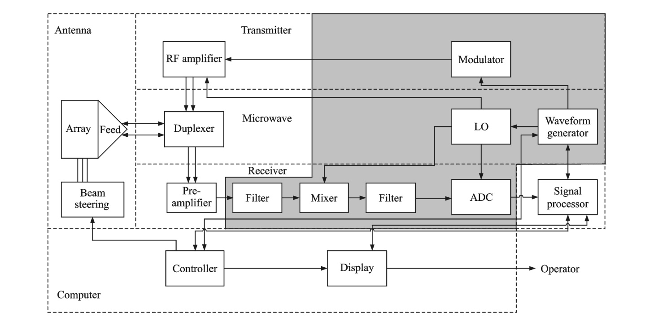
Fig. 1 Schematic diagram of a typical radar system
Figure tile：After the figure, composed of “Fig.” pluses a number, sentence case, centered, 9 pounds. “(a),(b),(c)” are used for sub-figures, and each sub-figure needs a title either.

On the other hand, microwave photonics, which brings new opportunities to revolutionize the microwave components and systems, has evolved significantly in scope and technical maturity over the past 30 years^{[10]}. As defined by many pioneers in this area^{[10-14]}, microwave photonics is an interdisciplinary field that studies the interactions between microwave and optical waves for the generation, processing, control, distribution and measurement of microwave, millimeter-wave and THz-frequency signals. Table 1 lists several key aspects of the performance difference between the conventional microwave system and the microwave photonic system. Thanks to the broad bandwidth, low loss, light weight, flat frequency response, and immunity to electromagnetic interference provided by the photonic technologies, microwave photonics may allow innovative implementation of the multiband reconfigurable radar with significant added value.
Figures and tables must be mentioned in the text closely ahead of their appearance.

Previously, there were considerable efforts devoted to applying the fast developing microwave photonic technologies to the radar systems, which can date back to the early 1990s^{[15-27]}. Examples include the trials to construct phased array radar based on photonic true time delay and the proposals to build photonic radio-frequency (RF) front-end. In 2009, the European Research Council (ERC) granted a project entitled PHODIR (Photonic-based full digital radar, Dec. 2009 - Dec. 2013), focused on the study, design and realization of a full
Table 1 Performance comparison between the conventional microwave system and microwave photonic system
Parameter | Microwave system  Table tile：Before the table, composed of “Table” pluses a number, sentence case, centered, 9 pounds. | Microwave photonic system
Frequency range | Tens of GHz | THz
Instantaneous bandwidth | Several GHz | Tens of GHz
Transmission loss / (dB·m^{－1}) | ~0.6 | 0.000 2
EMI | Serious | Immue
Weight | Heavy (EMI shielding) | Light
Isolation | Low | High

digital transceiver radar demonstrator based on photonic technology both for signal generation and for RF received signal processing^{[28]}. A photonic radar was built and demonstrated in a field trial at the port of Livorno, Italy. Based on PHODIR, another project PREPARE (Pre-industrial photonic-based radar design) was set up recently, aimed to address the research on the specific application for the airport security, providing a pre-industrial design. Meanwhile, the Europe seventh framework programme (FP7) established a project named GAIA (Photonics front-end for next-generation SAR applications, Oct. 2012—Oct. 2015), to develop the photonic technologies required in future array antenna systems for the implementation of the next generation synthetic-aperture radar (SAR) applications for future Earth observation missions^{[29]}.
In this paper, techniques developed in the last few years in microwave photonics that might change the way to design modern radar systems are reviewed. The recent advances in optoelectronic oscillators, arbitrary waveform generation, photonic mixing, phase coding, filtering, beamforming, analog-to-digital conversion, and stable RF signal transfer are described. Challenges in implementation of these components and subsystems for meeting the requirements of the radar applications are discussed.
1 Optoelectronic Oscillator
The ability of modern radar to detect low target signatures in clutter and hostile jamming environment is highly dependent on the quality of the transmitted signal, the receiver, and the data processing^{[30]}. As an essential part in the modern radars (as shown in Fig. 1), a microwave generator not only determines the quality of the RF signal in the transmitter and the intermediate frequency (IF) signal in the receiver, but also serves as a time standard for signal processing modules, by which, for example, the signal delay is measured to extract the range information. In modern radar systems, the phase noise of a microwave source is one of the key performance limiting factors^{[31-32]}. Due to the phase noise, weak targets would be hidden by strong unwanted echoes even if the echo from the target has Doppler shift. The spurious level is another key parameter of the microwave source which should be carefully considered in the radar systems. Without the high side mode-suppression ratio (SMSR), the false alarm probability will be significantly increased. Thanks to the capability of ultra-low phase noise microwave signal generation, OEOs^{[33-34]} have received much attention for potential radar applications in the past two decades. Fig.2 shows the schematic diagram of a typical OEO, which is a feedback loop consisting of an intensity modulator, a high-Q optical storage element (e. g. a length of fiber), a photodetector (PD), an electrical amplifier, an electrical bandpass filter (EBPF), and an electrical phase shifter. When a continuous-wave (CW) lightwave is injected into the modulator, the OEO starts to oscillate at one of its eigenmodes determined by the center frequency of the EBPF if the net gain of the loop is greater than unity. The spacing between two adjacent eigenmodes is determined by the total length of the loop.

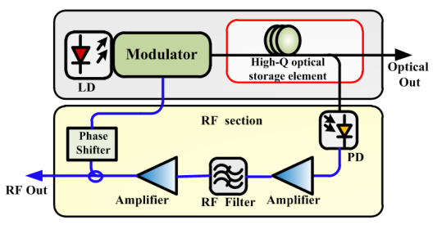

Fig.2 Block diagram of a typical OEO[34]
1.1 Phase noise performance of an OEO
Second level heading: Numbering is composed of chapter number , “.” and a section number, which starts at one. The second level heading is in sentence case, flush left, bolded, and 10 pounds.
The phase noise performance of an OEO is directly related to the Q-factor of the loop. In general, the longer the fiber in the OEO, the lower the phase noise^{[34]}. But the flicker noise of the amplifiers, the laser relative intensity noise (RIN), the shot noise in the PD and the noise introduced by the optical reflection would create a noise floor in the phase noise spectrum. Previously, considerable efforts were devoted to reduce this noise floor. By using amplifiers with lower flicker noise and high-Q filters, the phase noise performance was improved^{[35]}.
1.1.1 Laser RIN reduction
A fiber-optic implementation of the carrier-suppression technique was demonstrated to reduce the close-to-carrier noise of a triple-loop OEO^{[36]}.
Third level heading: Numbering is composed of the chapter number, “.” , the section number, “.” and a sub-section number, which starts at one. The third level heading is in sentence case, flush left, italicized, and 10 pounds.
replace the laser source, intensity modulator and PD, so that the OEO can be miniaturized by saving two devices and the corresponding drive circuits. The phase
•••••••••••••••••
noise with the generated 9.945 GHz signal is −101.31 dBc/Hz, showing that the compact OEO has an acceptable performance.
2 Photonic Arbitrary-Waveform Generation
For a radar system, the properties of the signal emitted by the antennas, such as the power, the temporal waveform, and the spectral bandwidth, will determine the detection range, resolution, and the anti-interference ability. In modern radar systems, programmable and diverse complicated waveforms are needed to increase the resolution and meet the fast-switching requirements, thus, AWG is becoming more and more important. In the current stage, the most commonly used electrical AWG in a radar system is realized by the direct digital frequency synthesis (DDS)^{[60]}. The DDS technology offers great flexibility for switchable waveform generation, but it suffers from the limited operation bandwidth which is usually lower than a few GHz. Because the radar systems are evolving towards working at high frequency and large bandwidth, optical arbitrary waveform generators (OAWGs) become a promising solution because it can generate high frequency and large bandwidth waveforms through optical technologies and then convert the optical signal into electrical arbitrary waveforms for radar applications. Besides the huge bandwidth, OAWG also features low cost, low loss and immunity to EMI,
etc. Up to now, several kinds of OAWG have been successfully demonstrated, showing the great potential for their use in radar systems.
An OAWG can be realized by optical spectral shaping followed by frequency-to-time mapping (FTTM)^{[61]}. Fig.3 shows the fundamental principle of this method. The system is usually composed of a pulsed laser source, an optical spectral shaper, a DE and a PD. The spectrum of the pulsed laser source is modified by the optical spectral shaper. Then, FTTM is performed in the DE, which can be a length of dispersive fiber or a chirped FBG. Mathematically, the impulse response of a DE is^{[62]}
$h\left(t\right)∝\exp\left(j\frac{π}{2\ddot{Φ}}t^{2}\right)$ (1)
where $\ddot{Φ}$ is the second-order dispersion of the DE. If the temporal width $∆t_{0}^{2}$ of the input pulse $a_{in}(t)$ is small enough to let $\left|∆t_{0}^{2}\right|≪\left|2π\ddot{Φ}\right|$, the output signal after the PD is^{[63]}
Parameters must be bold and italicized if they are matrixes, and vectors.
${I\left(t\right)=R\left|a_{out}(t)\right|}^{2}=C^{2}R{\left|F\left[a_{in}(t)\right]\right|}_{ω=t/{\ddot{Φ}}}^{2}$(2)
where C is a constant and F denotes the Fourier transformation, $R$ is the responsivity of the PD. As can be seen from Eq.(2), the generated electrical signal is a scaled version of the input optical power spectrum. As a result, by designing the optical spectral shaper with arbitrary power transfer function, arbitrary waveform can be generated.
All parameters should be explained after their fist appearance.

Fig. 3 Schematic diagram for waveform generation based on optical spectral shaping and FTTM

The key component in an OAWG based on spectral shaping and FTTM is the optical spectral shaper, which can be implemented based on free-space optics^{[64]} or fiber optics^{[65-67]}. Fig. 4 shows the structure of a typical optical spectral shaper, where the input optical pulse is first dispersed spatially by a grating and a spatial light modulator (SLM) array is used to implement optical spectral shaping before the dispersed light is combined by another grating. The advantage of using an SLM for spectral shaping is that the spectral response of an SLM can be updated in real time, making the generation of an arbitrary waveform possible. The main limitation of a

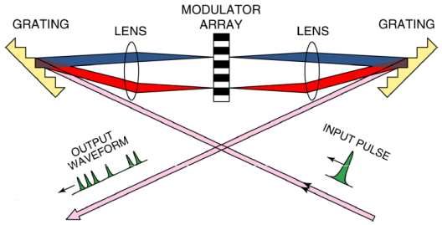

Fig.4 Optical spectral shaper based on free-space-optics^{[63]}
free-space-optics-based spectral shaper is the large size and high loss. In addition, the coupling between fiber to
free-space and free-space to fiber makes the system complicated. On the other hand, a spectral shaper can be implemented based on fiber optics. A fiber-optic spectral shaper has the advantages of smaller size, lower loss, and better compatibility with other fiber-optic components. For instance, a scheme for the generation of frequency and phase tunable pulsed microwave waveform based on spectral shaping and FTTM through all fiber optics is demonstrated with the schematic diagram shown in Fig.5(a). The optical spectral shaper is a tunable optical comb filter consisting of a differential group delay (DGD) element, a PolM and a polarizer^{[68]}. By passing a short optical pulse through the tunable comb filter and a DE, a pulsed microwave signal is generated after optical-to-electrical conversion. The phase of the generated microwave signal can be continuously tuned by tuning the voltage applied to the PolM, as shown in Fig.5(b). Thanks to the large bandwidth of the PolM, phase modulation of the microwave signal as high as tens of GHz can be achieved. Besides, the frequency of the microwave signal can be tuned by changing the DGD and/or the dispersion of the DE, as shown in Fig.3(c).
Another method for OAWG is Fourier pulse shaping based on an optical frequency comb (OFC). By manipulating the OFC to have certain amplitude and phase properties corresponding to the Fourier transformation of the target pulse waveform, the target waveform can be obtained in the time domain^{[69]}. The key issues for OAWG by Fourier pulse shaping is the generation of a wideband OFC and manipulating both the amplitude and the phase of the OFC. A mode locked laser (MLL) can generate an OFC with a comb line spacing being the same as the temporal interval between adjacent short pulses in the time domain^{[70]}. The method for OFC generation suffers from poor stability and a high cost, and it is also hard to obtain a flatted spectrum. A cost-effective approach to generating a stable and flat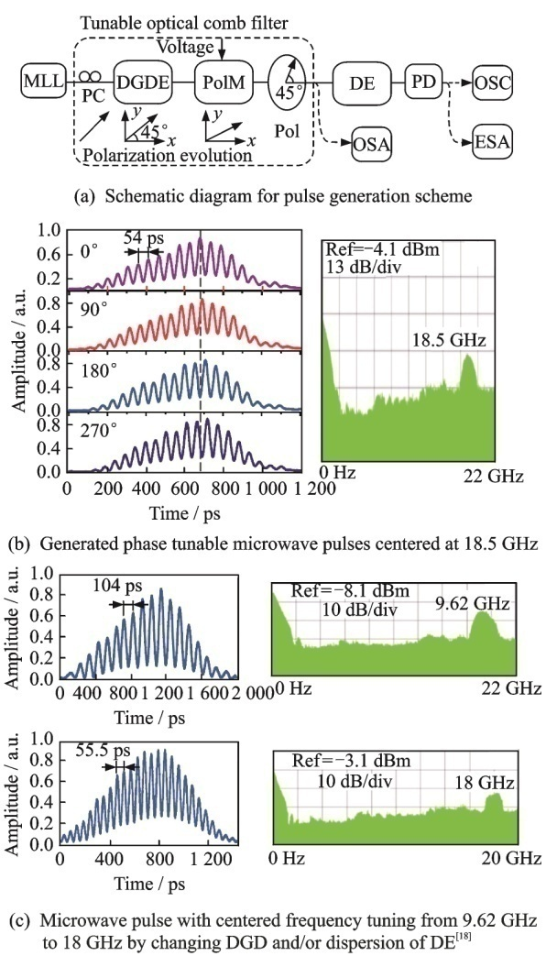
Physical quantities and their units (separated by “/”) must be noted either below the abscissa or besides the ordinate.
Fig.5 Schematic diagram for pulse generation and the experimental results
OFC is to modulate a CW light by electro-optic modulators^{[71-72]}. The flatness of the obtained OFC can be less than 1 dB in the power spectrum^{[71]}. To complete the Fourier pulse shaping based on the generated OFC, an optical processor that can manipulate the amplitude and phase of the comb is necessary. There have been commercially available optical processors that can perform this task, and the principle is almost the same as that shown in Fig. 4.
We have recently demonstrated an OAWG scheme based on Fourier pulse shaping^{[73]}. The OFC is generated by modulating a CW light through an electro-absorption modulator (EAM) and two cascaded electro-optic phase modulators (PMs), which has a comb line spacing of 40 GHz, 3 dB bandwidth of 3.8 nm and an optical signal-to-noise ratio (OSNR) of 40 dB. Then, using a commercially available programmable optical processor (Finisar Waveshaper-4000S) with a spectral resolution of 1 GHz, Fourier pulse shaping is implemented by designing the transfer functions of the optical processor
•••••••••••••••••
9 Discussion and Conclusions
This paper reviewed the recent development of microwave photonics for potential applications in radar systems, with an emphasis on the following technologies that are closely related to the radar functionality and performance: optoelectronic oscillators, arbitrary waveform generation, photonic mixing, phase coding, filtering, beamforming, analog-to-digital conversion, and stable radio-frequency signal transfer. These photonic technologies have been proved to have superior performance than their electrical counterparts, in terms of operation bandwidth, size, mass, and complexity, etc. Current research advances are encouraging, sufficiently showing the promising potentials of microwave photonics for radar applications, especially for future multifunctional and high performance radars. Despite the intense research activities carried out during the past three decades, there is still a considerable room for improvement. Several expected future developments are discussed as follows.
(1) The compatibility of different microwave photonic subsystems must be improved to integrate multiple microwave photonic functions in a single platform. The microwave photonic oscillators, arbitrary waveform generators, mixers, phase coders, filters, beamformers, analog-to-digital convertors are currently implemented based on different laser sources (i.e. CW, tunable, comb and pulsed laser sources), modulation schemes (i.e. phase modulation, intensity modulation, polarization modulation, and parallel or cascaded electrooptic modulation) and detection methods (i.e. direct detection, coherent detection, single-end or balanced detection). Some implementations require optical filtering, which may affect the realization of some other microwave photonic functions. The mechanism for adding tunablility or reconfigurability to some microwave photonic subsystem may also degrade the performance of other microwave photonic technologies.
(2) Continuous efforts should be devoted to the improvement of the performance of the devices and subsystems, while at the same time reducing the cost. Modern radars demand critically for large bandwidth, high sensitivity, large dynamic range of the RF systems. While microwave photonic technologies have superior performance in term of bandwidth, the sensitivity is low due to the high noise figure of the electrical-to-optical or optical-to-electrical conversion, and the dynamic range is relatively low because of the nonlinearity and low efficiency of the modulators and detectors.
(3) The microwave photonic systems must include antennas, RF amplifiers and other electronic devices or modules, but almost none of them is designed dedicatedly for the microwave photonic applications, which limited the potential of microwave photonics in practice. To solve this problem, hybrid design of the electrical and optical system is required.
(4) Most of the microwave photonic systems are realized based on discrete optical or electrical components, which is bulky, complicated, unstable, and power consuming. Photonic integrated circuit is a promising solution to this limitation. Significant advances were achieved in the past few years, and were recently reviewed in Ref.[159], but many microwave photonic functionalities are still not demonstrated on a chip. Therefore, more efforts to make the microwave photonic system compact, light, cheap, reliable and low power consuming are needed.
References:
Each reference starts with a number in square brackets, which is corresponding to the quoted number in the text, flush left.
Author’s name must be written in family name first (in capital) + the initial letter of given name. Only the first three authors’ names needed to be listed, the rest authors are noted as et al.

Samples of references:
- Book
PEEBLES P Z, Jr. Probability, random variable, and random signal principles[M]. 4th ed. New York: McGraw Hill, 2001.
BALDOCK P. Developing early childhood services: past, present and future[M/OL]. [S.l.]: Open University Press, 2011:105 [2012-11-27]. http://lib.myilibrary.com/Open.aspx?id=312377.
- Journal
KANAMORI H. Shaking without quaking[J]. Science,1998, 279(5359): 2063.
MYBURG A A, GRATTAPAGLIA D, TUSKAN G A, et al. The genome of Eucalyptus grandis[J/OL]. Nature, 2014, 510: 356-362(2014-06-19)[2014-06-25]. http://www.nature.com/nature/journal/v510/n7505/pdf/nature13308.pdf. DOI:10.1038/nature13308.
- Patent
TACHIBANA R, SHIMIZU S, KOBAYSHI S, et al. Electronic watermarking method and system: US6915001[P/OL]. 2005-07-05[2013-11-11]. http://
www.google.co.in/patents/US6915001.
- Online document
HOPKINSON A. UNIMARC and metadata: Dublin core[EB/OL]. (2009-04-22)[2013-03-27]. http://archive.
ifla.org/IV/ifla64/138-161e.htm.

- Collection

BABU B V, NAGAR A K, DEEP K, et al. Proceedings of the Second International Conference on Soft Computing for Problem Solving, December 28-30, 2012[C]. New Delhi: Springer, 2014.
- Report
CALKIN D, AGER A, THOMPSON M. A comparative risk assessment framework for wildland fire management: the 2010 cohesive strategy science report: RMRS-GTR-262[R]. [S.l.: s.n.], 2011:8-9.
- Dissertation
CALMS R B. Infrared spectroscopic studies on solid oxygen[D]. Berkeley: Univ. of California, 1965.
- Standard
Information and documentation-the Dublin core metadata element set: ISO 158369:2009[S/OL]. [2013-03-24].http://www.iso.org/iso/home/store/catalogue_tc/catalogue_detail.htm?csnumber=52142.

[1] SKOLNIK M I. Radar handbook [M]. 3rd Edition. New York: McGraw-Hill, 2008: 1-24.
[2] TAVIK G C, HILTERBRICK C L, EVINS J B, et al. The advanced multifunction RF concept [J]. IEEE Transactions on Microwave Theory and Techniques, 2005, 53(3): 1009-1020.
[3] SADDIK G N, SINGH R S, BROWN E R. Ultra-wideband multifunctional communications/radar system [J]. IEEE Transactions on Microwave Theory and Techniques, 2007, 55(7): 1431-1437.
[4] HU S, XIONG Y Z, WANG L, et al. A 77—135GHz down-conversion IQ mixer for 10Gbps multiband applications [C]// the 13th International Symposium on Integrated Circuits (ISIC). Singapore: IEEE, 2011: 29-34.
modulator-based photonic microwave phase shifter [J]. Optics Letters, 2013, 38(5): 766-768.

•••••••••••••••••
[147] GHELFI P, MA L, WU X, et al. All-optical parallelization for high sampling rate photonic ADC in fully digital radar systems [C]// Optical Fiber Communication Conference. San Diego: Optical Society of America, 2010: OThU6.
[148] KHILO A, SPECTOR S J, GREIN M E, et al. Photonic ADC: overcoming the bottleneck of electronic jitter [J]. Optics Express, 2012, 20(4): 4454-4469.
[149] SCOTTI F, LAGHEZZA F, PINNA S, et al. High precision photonic ADC with four time-domain-
demultiplexed interleaved channels [C]// 2013 OptoElectronics and Communications Conference & 2013 International Conference on Photonics in Switching (OECC/PS), Kyoto: IEEE, 2013: 1-2.
[150] TAYLOR H F. An electrooptic analog-to-digital converter [J]. Proceedings of the IEEE, 1975, 63(10): 1524-1525.
[151] LI W, ZHANG H, WU Q, et al. All-optical analog-to-digital conversion based on polarization-differential interference and phase modulation [J]. IEEE Photonics Technology Letters, 2007, 19(8): 625-627.
[152] SARANTOS C, DAGLI N. A photonic analog-to-digital converter based on an unbalanced Mach-Zehnder quantizer [C]// 2007 IEEE International Topical Meeting on Microwave Photonics, Victoria, BC, 2007: 58-61.
[153] CHEN Y, CHI H, ZHENG S, et al. Differentially encoded photonic analog-to-digital conversion based on phase modulation and interferometric demodulation [J]. IEEE Photonics Technology Letters, 2011, 23(24): 1890-1892.
[154] WANG Y, ZHANG H, WU Q, et al. Improvement of photonic ADC based on phase-shifted optical quantization by using additional modulators [J]. IEEE Photonics Technology Letters, 2012, 24(7): 566-568.
[155] HOLMAN K W, HUDSON D D, Ye J, et al. Remote transfer of a high-stability and ultralow-jitter timing signal [J]. Optics Letters, 2005, 30(10): 1225-1227.
[156] WU Z, DAI Y, YIN F, et al. Stable radio frequency phase delivery by rapid and endless post error cancellation [J]. Optics Letters, 2013, 38(7): 1098-1100.
[157] HE Y, ORR B J, BALDWIN K G H, et al. Stable radio-frequency transfer over optical fiber by phase-conjugate frequency mixing [J]. Optics Express, 2013, 21(16): 18754-18764.
[158] WEI J, PAN S L, ZHANG F Z, et al. Post Phase Correction for stable fiber delivery of radio-frequency signal [C]. Submitted to 2014 International Microwave Symposium (IMS2013).
[159] MARPAUNG D, ROELOFFZEN C, HEIDEMAn R, et al. Integrated microwave photonics [J]. Laser & Photonics Reviews, 2013, 7(4): 506-538.
Acknowledgement(s)：”Acknowledgement” begins with a capital letter, bolded, flush left and 10 pound. The text starts intended, 10 pounds.
… …
Acknowledgements This work was supported in part by the National Basic Research Program of China (No. 2012CB315705), the Natural Science Foundation of Jiangsu Province (Nos. BK2012031, BK2012381), the National Natural Science Foundation of China (Nos.61201048, 61107063), and the Fundamental Research Funds for the Central Universities. The authors realize that the time and space available for a review of such an ambitious subject are limited and, thus, regretfully, we are unable to cover many important contributions. The authors would like to acknowledge the following people for their assistance: Fu Jianbin, Huang Menghao, Zhang Yamei, Wei Juan, Tang Zhenzhou, Gu Xiaowen, Ye Xingwei, and Wu Huan, all with the Key Laboratory of Radar Imaging and Microwave Photonics, Ministry of Education, Nanjing University of Aeronautics and Astronautics.
Author Prof. PAN Shilong received the B.S. and Ph.D. degrees in electronics engineering from Tsinghua University, Beijing, China, in 2004 and 2008, respectively. From 2008 to 2010, he was a “Vision 2010” Postdoctoral Research Fellow in the Microwave Photonics Research Laboratory, University of Ottawa, Ottawa, ON, Canada. From 2010 to present, he has been with the College of Electronic and Information Engineering, Nanjing University of Aeronautics and Astronautics (NUAA), where he is currently a full professor and executive director of the Key Laboratory of Radar Imaging and Microwave Photonics (NUAA), Ministry of Education. His research has focused on microwave photonics, which includes Radio over fiber, photonic generation of microwave, mm-wave and THz, photonic processing of microwave signals, photonic microwave measurement and photonic integrated circuits.
Brief CV of each author should be provided.
Prof. ZHU Dan received the B.S. and Ph.D. degrees in electronics engineering from Tsinghua University, Beijing, China, in 2004 and 2009, respectively. In July 2009, she joined the Research Department of Radar Signal Processing, No.14 Research Institute, China Electronics Technology Group Corporation, as a researcher. In May 2011, she joined the Photonic Microwave Research Laboratory, College of Electronic and Information Engineering, NUAA, Nanjing, China. From Jul. 2014, she works as a visiting scholar in the Microwave Photonics Research Laboratory, University of Ottawa, Canada.
Dr. ZHANG Fangzheng received B.S degree in Physics from Huazhong University of Science and technology in 2008 and Ph.D. degree in Electronic Engineering from Beijing University of Posts and Telecommunications in 2013, respectively. He joined in Nanjing University of Aeronautics and Astronautics in June 2013, where he is an assistant professor of Microwave Photonics Research Laboratory. His research is focused on high speed coherent optical communication, the optical information processing and relevant fields.
Author contributions Prof. PAN Shilong designed the study. Dr. ZHAO Dan wrote the manuscript. Dr. ZHANG Fangzheng contributed data for the damage detection part. All authors commented on the manuscript draft and approved the submission. (仅供参考)
Competing interests The authors declare no competing in⁃terests.

（Production Editor： ）

