Steady-State Cornering Properties of a Non-Pneumatic Tire with Mechanical Elastic Structure

Fu Hongxun, Zhao Youqun*, Lin Fen, Du Xianbin, Zhu Mingmin
College of Energy and Power Engineering, Nanjing University of Aeronautics and Astronautics, Nanjing 210016, P. R. China
(Received 29 February 2016; revised 13 April 2016; accepted *** 2016)

Abstract: Mechanical elastic wheel (ME-wheel) is a new type of non-inflatable safety tyre, and the structure is significantly different from traditional pneumatic tyre. In order to investigate cornering properties of ME-wheel, experimental research on mechanics characteristics of ME-wheel under steady-state cornering conditions were carried out. The test of steady-state cornering properties of ME-wheel at different experimental parameters conditions was conducted by test bench for dynamic mechanical properties of tyre. Cornering properties curves were used to analyze the steady-state cornering properties of ME-wheel, namely the variation tendency of lateral force or aligning torque with the increase of side-slip angle. Moreover, evaluation indexes for cornering properties of ME-wheel were extracted and the effect of different experimental parameters (including vertical load, friction coefficient, and speed) on cornering properties of ME-wheel was contrastively analyzed. The research in this paper could provide certain reference to facilitate structure parameters and cornering properties optimizing process of ME-wheel.
Key words: Tyres; non-pneumatic tyres; mechanical elastic structure; steady-state cornering properties
CLC number：U461.2 Document code: A Article ID: ***

0 Introduction
Tyre is an important part of vehicle, which affects driving performance of vehicle. With the growing requirements of improving vehicle safety performance, safety problems existing in pneumatic tyres such as puncture or blasting are increasingly prominent, and study on tyre safety technology is also growing. According to related research, tyre safety technology can be divided into two main categories, namely run-flat technology^{[1-3]} and non-pneumatic technology^{[4-7]}. The former refers to improving safety performance of traditional pneumatic tyres, without changing basic structures and performance of pneumatic tyres. The latter refers that tyres replace encapsulated pressurized air in pneumatic tyres with elastic structure, which makes the tyres not pricked or punctured. The development of non-pneumatic tyres (NPTs) is increasingly being concerned, owing to potential advantages over pneumatic tyres in terms of no run-flat, no need of air pressure maintenance, and low rolling resistance. NPTs’ advantages decide their usage in vehicles of military, engineering, and so on. Mechanical elastic wheel (ME-wheel) which studied in this paper is a kind of NPTs.
Based on theoretical analysis, numerical simulation or experimental methods, a lot of research work on mechanical properties of NPTs has already been carried out. Rhyne et al.^{[4]} analyzed load-bearing deformation characteristics of TweelTM. Gasmi et al.^{[8]} presented a quasi-static two-dimensional analytical model for a compliant non-pneumatic tire to study the effect of structure parameters on contact patch, vertical stiffness and rolling resistance. Veeramurthy M et al.^{[9]} investigated the effect of geometric and material parameters of a NPT on rolling resistance, vertical stiffness and contact pressure. Ju et al.^{[10]} studied a non-pneumatic tire with flexible cellular solid spokes for realizing high fatigue resistance design. Dynamic properties were also studied to reduce vibration during an NPT’s high speed rolling ^{[11-13]}. Li B et al.^{[14]} presented a driving force model for non-pneumatic elastic wheel.
Despite numerous studies on mechanical properties of NPTs, such as vertical, longitudinal, contact characteristics et al, there is little research on lateral mechanical properties of NPTs, especially cornering characteristics. Tyre cornering properties, namely the relationship between lateral force or aligning torque and side-slip angle under cornering conditions, are main influence factors of vehicle handling stability performance.^{[15]} At the same time, tyre cornering properties also affect useful life and wear resistance property of tyres. Therefore, it is important to investigate cornering properties of ME-wheel for both theoretical analysis and practical application.
1 Structure and load-carrying mechanism of ME-wheel
ME-wheel consists of tyre bead, hinge-groups, rigid hub and other components, as shown in Fig.1. Breaking traditional separated design between pneumatic tyre and wheel, ME-wheel adopts non-pneumatic structure which uses hinge-groups to connect tyre bead and rigid hub. So it seems impossible for ME-wheel to burst or be punctured. Tyre bead is made of rubber layer and elastic ring group which is packed in the rubber layer. Elastic ring group consists of elastic rings and elastic ring clamps which are circumferential distribution with uniform angle around elastic rings. Hinge-group is made up of three hinges, and its length is slightly larger than the fit clearance. Rigid hub is placed in the middle of tyre bead, and it hangs on tyre bead with hinge-groups, so it is also called hang hub.
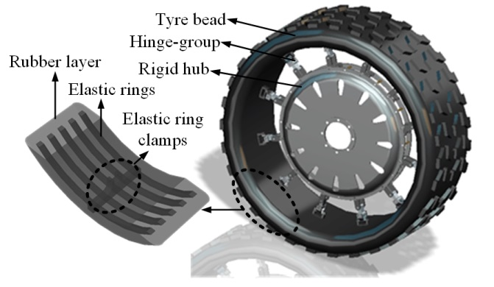
Fig.1 Basic components of ME-wheel
According to load-carrying mechanism, there are two bearing ways for the wheels and tyres, namely bottom-loader and top-loader, as shown in Fig.2. Bottom-loader carries load through direct compression from the contact area to wheel hub. Therefore, only a small part of the wheel is involved in carrying the load at any instant. The typical structure of bottom-loader is rigid wheels and solid tyres. The typical structure of top-loader is tensioned spoke wheel. A small deformation of the rim by the contact force reduces the spoke tension locally. The vector sum of the spoke tensions gives the load carried by the wheel. The load is thus suspended from the arch of the wheel above the hub. All of the structure is involved in carrying the load at each instant. The above analysis shows that ME-wheel functions as a top-loader, namely the load is distributed from rigid hub up through the hinge-groups to the arch of tyre bead.
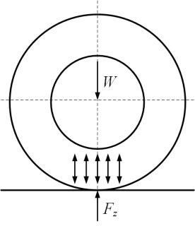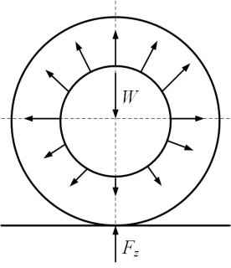
(a) Bottom-loader (b) Top-loader
Fig.2 Load-carrying mechanism of traditional wheels
The deformation diagram of ME-wheel under vertical and lateral force is shown in Fig.3. When ME-wheel bears vertical load, tensile force which transfers from hub by hinge-groups to elastic ring acts on upper part of tyre bead, while ground reaction force acts on lower part. These forces make tyre bead elastic deformation from circle to similar ellipse. Though there is no force acting on hinge-groups around contact area, they curve naturally which caused by the deformation of tyre bead. Other hinge-groups are subjected to tension. When ME-wheel bears lateral force from the ground, lateral deformation of hinge-groups does not occur due to the design of horizontal configuration. Only tyre bead around contact area generates lateral deformation.
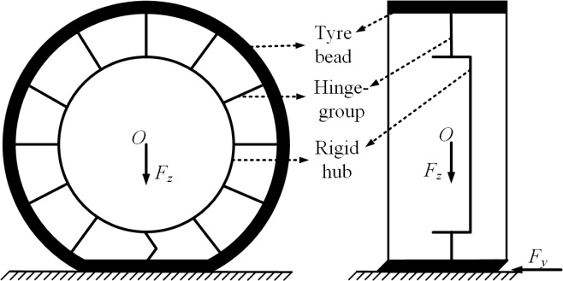
Fig.3 Deformation diagram of elastic mechanical wheel under vertical and lateral force
2 Experimental design of steady-state cornering properties of ME-wheel
2.1 Test facility
The basic structure of test bench for dynamic mechanical properties of tyre is presented in Fig. 4. It is mainly composed of drive motor, vertical loading mechanism, angle governing mechanism, sliding plate, guide rail and test data acquisition system. It is up to drive motor to realize right and left translation of sliding plate. The vertical loading mechanism is used to complete the loading in vertical direction of tyre. The angle between tyre and guide rail are adjusted through angle governing mechanism. The different friction coefficient of road surface is simulated through sliding plate. Test data acquisition system is made up of several parts, including three dimensions force sensors, torque sensor, digital display meter, and so forth. Three dimension force sensor can measure the vertical loading and lateral force of tyre, and torque sensor can measure the aligning torque of tyre.
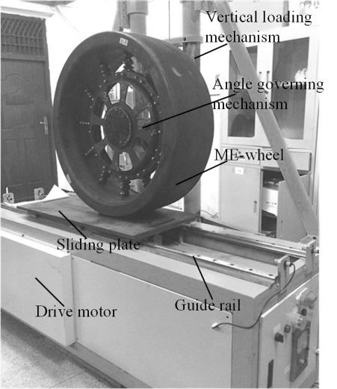
Fig.4 Basic structure of test bench for dynamic mechanical properties of tyre
The test bench about dynamic mechanical properties of tyre is used to complete the cornering experiment, its basic principles is introduced as following. Test tyre is adjusted to a certain angle, namely the side-slip angle, by angle governing mechanism. The wheel was employed to impose the specified vertical load F_{z} through vertical loading mechanism. The specified vertical loading F_{z} are strictly restricted by the collected data from three dimensions force sensors. Drive motor drives the sliding table from side to the other side as a certain speed. The sampling ranges in the sliding plate are set. Three dimension force sensor is used to gathering cornering force F_{y}, and torque sensor is used to gathering aligning torque M_{z}. Multiple sets of tests are carried out by repeating the steps according to the above predicting procedure. In particularly, it should smear a layer of talc evenly over the sliding plate to maintain uniform and stability of friction force.
2.2 Experimental content
The test of steady-state cornering properties of a certain type of ME-wheel has been carried out by the test bench for dynamic mechanical properties of tyre, as shown in Fig.4. The basic structural parameters of ME-wheel in test included the nominal outside diameter and sectional width of tyre bead, the value is 940 mm and 315 mm respectively.
The specific content of test is as follow: (1) the mechanical properties of ME-wheel in the condition of steady-state cornering; (2) different experimental parameters are set to research their effects on cornering properties of ME-wheel. The specific settings of working condition in test are presented in Table 1.
Table 1 Experimental parameters of steady-state cornering
Experimental parameters | Value
Side-slip angle /(deg) | 0~20
Vertical loading /(kN) | 10, 15, 20
Friction coefficient | 0.47, 0.79
Velocity of slipway /(km·h⁻¹) | 20, 40, 60
Heeling angle /(deg) | 0
Longitudinal slippage ratio | 0
3 Result and discussion
3.1 Steady-state cornering properties of ME-wheel
Experimental results of steady-state cornering characteristics of ME-wheel at different vertical load conditions are shown in Fig.5.
(a) Lateral force F_{y} vs side-slip angle α
(b) Aligning torque M_{z} vs side-slip angle α
Fig.5 Steady-state cornering characteristics of ME-wheel at different vertical load conditions
The results as shown in Fig.5(a) reveal that under the condition of vertical load F_{z}=15 kN, lateral force F_{y} increases linearly with the increase of side-slip angle α. When side-slip angle is bigger than about 8°, lateral force increases slowly. With side-slip angle continues to increase, lateral force is close to its limit. In other conditions, the relation curves of F_{y}-α show similar trend, while the limit value changes with diffident vertical load. The main causes of change trend are as follows：(1) with a certain vertical load, lateral distributive stiffness and contact length of ME-wheel remain the same, so cornering stiffness basic remain unchanged, as a result, when side-slip angle is small， lateral force has approximate linear increase with the augment of side-slip angle；(2) with the increase of side-slip angle, lateral force increases to the limit, namely the maximum friction between wheel and road surface; (3) the side-slip angle continues to increase, lateral force no longer increases and side sliding of ME-wheel occurs.
The results as shown in Fig.5(b) reveal that aligning torque M_{z} presents nonlinear variation with the increase of side-slip angle α. When side-slip angle is 0°~4°, aligning torque increases rapidly with the increase of side-slip angle. When side-slip angle is around 4°, aligning torque attains to the maximum. When side-slip angle increases from 4° to 12°, aligning torque decreased sharply. As side-slip angle increases sequentially, aligning torque declines slowly. The trend of M_{z}-α relation curves are similar in other conditions, while vertical load affects the maximum of aligning torque, namely the maximum of aligning torque gets bigger with vertical load grows. The main causes of change trend are as follows：(1) when the side-slip angle is small, with the increase of side-slip angle, lateral strain of tyre bead unit in the contact area increases, lateral stress also increase, so that resultant of lateral stress generates backward-shift and wheel trail increases, then aligning torque increases; (2) with the increase of side-slip angle, lateral strain of tyre bead reaches limit, and the wheel starts creating slippage; (3) side-slip angle continues to increase, slip area extends forward, which makes resultant of lateral stress generates forward-shift, wheel trail decreases, and aligning torque decreases; (4) when all contact area begins to slip, wheel trail decreases to zero or negative, then aligning torque reduced to zero or negative.
3.2 Influence of experimental parameters on wheel cornering properties
It can be obtained the experimental data of tire cornering under different experimental parameters by the test of ME-wheel steady state cornering performance. The test data is processed and the characteristic curves are drawn. Characteristic curves under different experimental parameters show that the trend of lateral force and aligning torque along with the change of side-slip angle is basically the same. Cornering stiffness, aligning stiffness, the peak of lateral force and aligning torque are chosen from cornering properties curves as evaluation indexes of cornering properties. The evaluation indexes are used to research the specific influence of different experimental parameters on cornering properties of ME-wheel.
The comparison of evaluation indexes for the cornering characteristics of ME-wheel under different vertical load is shown in Fig.6. Cornering stiffness, aligning stiffness, the peak of lateral force and aligning torque of wheel are affected by vertical load. With the increase of vertical load, cornering stiffness, aligning stiffness, the peak of lateral force and aligning torque of wheel increase in all. The main causes of change trend are as follows：(1) with the increment of vertical load, lateral stiffness of ME-wheel increases, so that lateral force needs to generate the corresponding side-slip angle increase, thus cornering stiffness increases; (2) with the increase of vertical load, friction coefficient decrease, but the decrease amplitude is significantly less than the increase amplitude of vertical load, so lateral force peak increases with the increment of vertical load; (3) with the increase of vertical load, contact length increases, wheel trail increases, cornering stiffness and lateral force are increased as well, so are aligning stiffness and aligning torque peak.
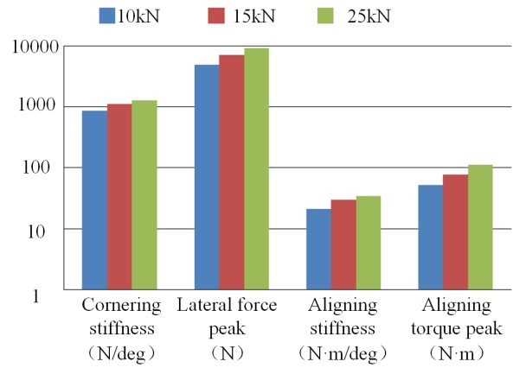
Fig.6 Comparison of evaluation indexes for cornering characteristics of ME-wheel under different vertical load
The comparison of evaluation indexes for the cornering characteristics of ME-wheel on different friction coefficient is presented in Fig.7. From the graph it may be seen that friction coefficient has significant influence on the peak of lateral force and aligning torque of wheel, yet which has no obvious influence on the cornering stiffness and aligning stiffness. With an increase in the friction coefficient, the peak of lateral force and aligning torque increased evidently, while the cornering stiffness and aligning stiffness remain almost no changes. The main causes of change trend are as follows. Lateral force peak is equal to vertical load and friction coefficient. Friction coefficient increases, lateral force peak increases, aligning torque also increases. Under the working condition of small side-slip angle, friction coefficient has no effect on the lateral force and contact length, so cornering stiffness and aligning stiffness remain the same.
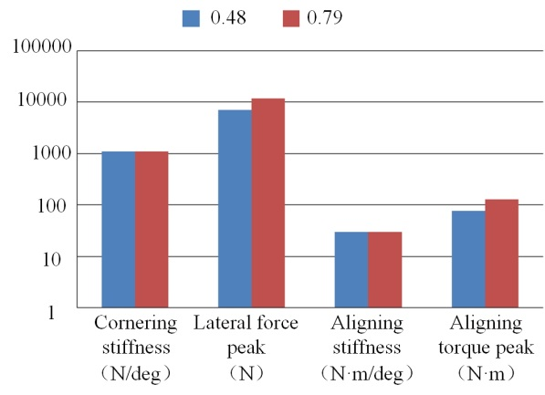
Fig.7 Comparison of evaluation indexes for the cornering characteristics of ME-wheel on different friction coefficient
The comparison of evaluation indexes for the cornering characteristics of ME-wheel on different speed is shown in Fig.8. It can be seen that the speed has little influence on cornering properties of wheel at low speed; evaluation indexes for the cornering characteristics remains almost the same with the rate increase. At high speed, the speed has great influence on the peak of lateral force and aligning torque, but it has little influence on the cornering stiffness and aligning stiffness. The peak of lateral force and aligning torque has an evidently decreasing tendency, and the cornering stiffness and aligning stiffness remain almost no changes. The main reason why appeared this kind of situation is the friction coefficient reduces between the ME-wheel and slipway with the speed increases in high rate working condition.
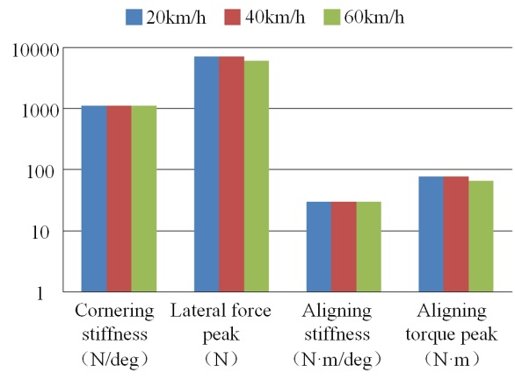
Fig.8 Comparison of evaluation indexes for the cornering characteristics of ME-wheel on different speed
4 Conclusions
In this study, experimental methods are used to investigate steady-state cornering properties of ME-wheel. The major findings through these studies are as follows:
(1) Lateral force and aligning torque of ME-wheel present nonlinear variation with the change of side-slip angle. With the increase of side-slip angle, lateral force first linearly increases and then remains the limit, aligning torque first increases and then decreases. When side-slip angle is about 4°, aligning torque attains to the maximum.
(2) Vertical load has a significant influence on cornering properties. With the increase of vertical load, cornering stiffness, aligning stiffness, peak of lateral force and aligning torque increase in all.
(3) Friction coefficient and speed have a certain influence on cornering properties. With an increase in friction coefficient, peaks of lateral force and aligning torque of wheel increases. At high speed, with the speed increases, peak of lateral force and aligning torque has an evidently decreasing tendency, and cornering stiffness and aligning stiffness remained almost no changes.
Acknowledgement
This work was supported by explore research project of the general armament department (NHA13002) and the Fundamental Research Funds for the Central Universities (NP2016412).
References:
[1] Cho J R, Lee J H, Jeong K M, et al. Optimum design of run-flat tyre insert rubber by genetic algorithm[J]. Finite Elements in Analysis & Design, 2012, 52(7):60-70.
[2] Ejsmont J A, Jackowski J, Luty W, et al. Analysis of rolling resistance of tyres with run flat insert[J]. Key Engineering Materials, 2014, 597: 165-170.
[3] Tong J, Yang X, Zhang F, et al. Development of run-flat tire technology[J]. Transactions of the Chinese Society of Agricultural Machinery, 2007, 38(3): 182-187.
[4] Rhyne T B, Cron S M. Development of a non-pneumatic wheel[J]. Tire Science & Technology, 2006, 34(3): 150-169.
[5] Ju J, Summers J D. Compliant Hexagonal Periodic Lattice Structures Having Both High Shear Strength and High Shear Strain[J]. Materials & Design, 2011, 32(2): 512-524.
[6] Ju J, Veeramurthy M, Summers J D, et al. Rolling resistance of a non-pneumatic tyre having a porous elastomer composite shear band[J]. Tire Science & Technology, 2013, 41(3):154-173.
[7] Li B, Zhao Y Q, Zang L G. Closed-form solution of curved beam model of elastic mechanical wheel [J]. Journal of Vibroengineering, 2014, 16(8): 3951-3962.
[8] Gasmi A, Joseph P F, Rhyne T B, et al. Development of a two-dimensional model of a compliant non-pneumatic tyre[J]. International Journal of Solids & Structures, 2012, 49(13): 1723-1740.
[9] Veeramurthy M, Ju J, Thompson L L, et al. Optimizations of geometry and material properties of a non-pneumatic tyre for reducing rolling resistance[J]. International Journal of Vehicle Design, 2014, 66(2): 193-216.
[10] Ju J, Kim D M, Kim K. Flexible cellular solid spokes of a non-pneumatic tyre[J]. Composite Structures, 2012, 94(8): 2285-2295.
[11] Zhao Y Q, Zang L G, Chen Y Q, et al. Non-pneumatic mechanical elastic wheel natural dynamic characteristics and influencing factors[J]. Journal of Central South University, 2015, 22(5): 1707-1715.
[12] Rutherford W, Bezgam S, Proddaturi A, et al. Use of orthogonal arrays for efficient evaluation of geometric designs for reducing vibration of a non-pneumatic wheel during high-speed rolling[J]. Tire Science & Technology, 2010, 38(4): 246-275.
[13] Narashmhan A, Ziegert J, Thompson L. Effects of material properties on static load-deflection and vibration of a non-pneumatic tire during high-speed rolling. SAE International Journal of Passenger Cars-Mechanical Systems, 2011, 4(1): 59-72.
[14] Li B, Zhao Y Q, Zang L G, et al. Driving Force Model for Non-pneumatic Elastic Wheel[J]. Transactions of Nanjing University of Aeronautics & Astronautics, 2016, 33(2): 231-236.
[15] Pacejka H. Tire and vehicle dynamics. 2th Edition. London: Butterworth, 2006: 96.

机械弹性结构非充气车轮的稳态侧偏特性
付宏勋，赵又群，林棻，杜现斌，朱明敏
(南京航空航天大学能源与动力学院，江苏 南京 210016)
摘要：机械弹性车轮是一种新型非充气安全轮胎，其结构形式与充气轮胎存在明显区别。为掌握机械弹性车轮的侧偏特性，对车轮稳态侧偏工况下的力学特性进行了试验研究。利用自行研制的轮胎动态力学特性试验台架，对机械弹性车轮样机进行了不同试验参数下的稳态侧偏特性试验。基于侧偏特性曲线，对机械弹性车轮的稳态侧偏特性进行了分析，得到了车轮侧向力、回正力矩与侧偏角的关系。提取机械弹性车轮侧偏特性评价指标，并对比分析了不同试验参数（包括垂向载荷、摩擦系数以及速度）对车轮侧偏特性的影响。本文的研究可为改进车轮结构及改善车轮侧偏性能等提供一定的参考。
关键词：轮胎；非充气轮胎；机械弹性结构；稳态侧偏特性

